Name:________________ Date:_______________
ENZYMES notes
Speed up or allow
Chemical reactions
To take place without being “used up” in the process
Metabolism sum of all the chemical reactions in body
Interactions of matter and energy
Protein (catalyst)
ENZYMES

Enzyme function:
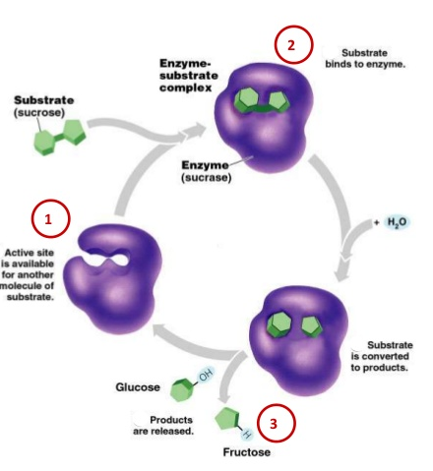
Model 1: Lock and Key: Terms and things to note:
Which process is shown here? (hydrolysis)
Why is the shape so important? Shape determines function = enzyme to breakdown sucrose

Enzyme prefix “matches” the substrate
Active site with shape for substrate to “fit”

Enzyme names end in –ase

Enzyme is not used up in the chemical reaction, and is still available for more substrate

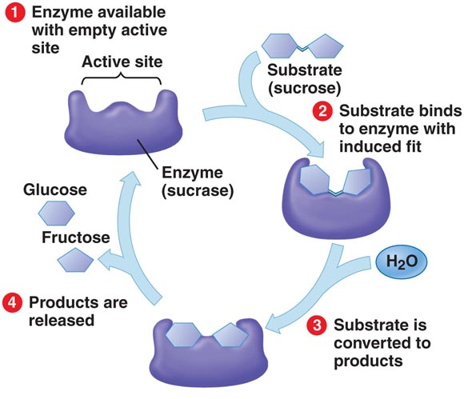
Model 2: Induced Fit
This is the most widely accepted model for how enzymes work….
In induced fit model the shape of the enzyme can slightly change while interacting with the substrate. The end results and the concept of shape of the enzyme affecting function are the same.
Like putting a rubber glove on your hand

Factors that affect enzyme function: Another Goldilocks situation….
TEMPERATURE:
How does having a fever equate to you being cooked like an egg?
The proteins in your body will denature lose their shape if the temperature is too hot.
Temperature = measure of heat
More heat = faster molecule movement and more collisions
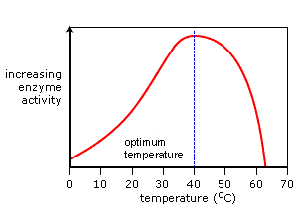
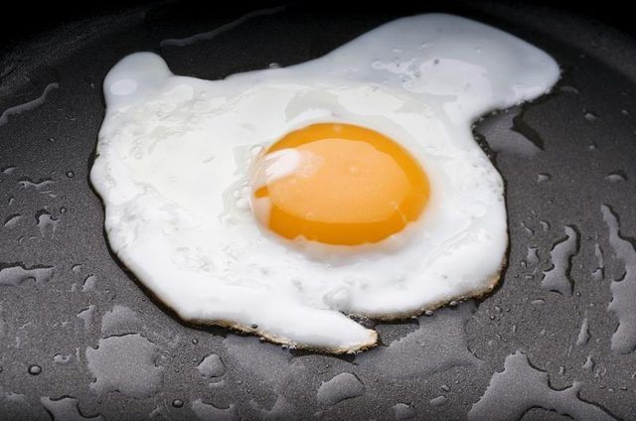
IF IT IS TOO HOT = Denatured protein
Slow rate of reaction
Food lasts longer
better chance of enzyme and substrate collision
Think Eggies … once you cook the eggs at a certain temperature the protein denatures (loses it shape) and can no longer go back to the way it was.
Same thing applies to the proteins in your body
Very little heat = slow molecule movement
faster rate of chemical reactions

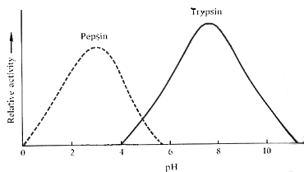
pH:
The pH also effects the rate of reaction. If the pH is too high or low for a particular enzyme it will denature.

What is the optimum pH for pepsin? _____
What is the optimum pH for Trypsin? _____

Pepsin is a protein that helps to break down the proteins you eat. Where do you think this enzyme is located in your body? Why?
Stomach= very acidic with pH of ~3 which matches the ideal pH of pepsin
Amount of substrate:
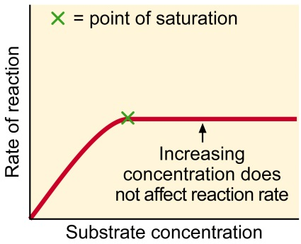
As substrate concentration increase so does the reaction rate… until every enzyme is “busy” with a substrate molecule At all times.

Amount of enzyme:
Similarly if you increase the enzyme concentration once enough enzymes are present to engage every substrate molecule an extra enzymes will have “nothing to do” and therefore not help increase the rate of reaction.
Enzyme concentration

Name:________________ Date:_______________
ENZYMES notes
Speed up or allow

_________________ - sum of all the chemical reactions in body
Interactions of matter and energy
Protein
ENZYMES

Enzyme function:
Model 1: Lock and Key: Terms and things to note:
Which process is shown here?
Why is the shape so important?

Enzyme prefix “matches” the substrate
______________ _________ with shape for substrate to __________

Enzyme names end in –ase

Model 2: Induced Fit
This is the most widely accepted model for how enzymes work….
In induced fit model the shape of the enzyme can ___________ _____________ while interacting with the substrate. The end results and the concept of shape of the enzyme affecting function are the same.
Like putting a rubber glove on your hand

Factors that affect enzyme function: Another Goldilocks situation….
TEMPERATURE:
How does having a fever equate to you being cooked like an egg?
The proteins in your body will denature lose their shape if the temperature is too hot.
Temperature =
More heat =
IF IT IS TOO HOT =
Slow
Food lasts
better chance of
Think Eggies … once you cook the eggs at a certain temperature the protein __________________________ and can no longer go back to the way it was.
Same thing applies to the proteins in your body
Very little heat =
faster rate

pH:
The pH also affects the rate of reaction. If the pH is too high or low for a particular enzyme it will denature.

What is the optimum pH for pepsin? _____
What is the optimum pH for Trypsin? _____

Pepsin is a protein that helps to break down the proteins you eat. Where do you think this enzyme is located in your body? Why?

Amount of substrate:
As substrate concentration increase so does the reaction rate… until every enzyme is “busy” with a substrate molecule At all times.

Amount of enzyme:
Similarly if you increase the enzyme concentration once enough enzymes are present to engage every substrate molecule an extra enzymes will have “nothing to do” and therefore not help increase the rate of reaction.
Enzyme concentration

